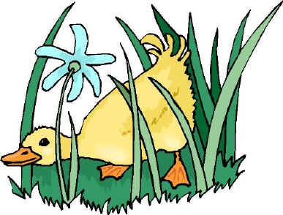

MAY and JUNE

NEWSLETTER

march

Newsletter!

Mrs. Halewicz & Mrs. Kohn

**The end of the year is almost here! We have some important upcoming events, so make sure to mark your calendars!**

**PRESCHOOL GRADUATION**

**Up Coming Events!**

We will have a short program on **Tuesday, June 3rd** at 6 pm in the Preschool Classroom. Please return the attached invitation so we know how many people to expect. ***Please write the number of people that will be attending!***

**May 21st- Early Dismissal- School will end at 12:05pm.**

**May 26th- NO SCHOOL Memorial Weekend**

**May 29th- Zoo Field Trip**

**June 3rd- PRESCHOOL LAST DAY!**

**June 3rd- End of Year Celebration**

**LAST DAY OF SCHOOL FOR JUST 4s.**

REMINDER: The last day of school for your preschooler is June 3rd.

**THEMES**

**FIELD TRIPS**

Outdoors/Spring

Insects

Nursery Rhymes

Oodles of Bubbles

Kindergarten Readiness

Our field trip to the John Ball Zoo is May 29th. Please make sure you hand in your permission slip ASAP. If you need a new one please let me know.



**HOME VISITS**

**CHICKS!**

Part of our program is two required home visits a school year. We have *ALL* the home visits scheduled!! I will send reminders home before we come☺ Thanks everyone for signing up for home visits is a timely manner!

We would love to hatch Chicks in our Classroom but we need to get some eggs first. If anyone knows where I can get some chicken eggs please let me know! Thank You ☺



**Please visit our website at**

**mrshalewicz.weebly.com**

**THINGS TO PRACTICE AT HOME:**

**Getting dressed and un-dressed (includes outerwear, Counting, Writing Name, Letters/Sounds, Solving problems on their own, Draw/Write in a notepad and**

**Reading! Reading! Reading!**